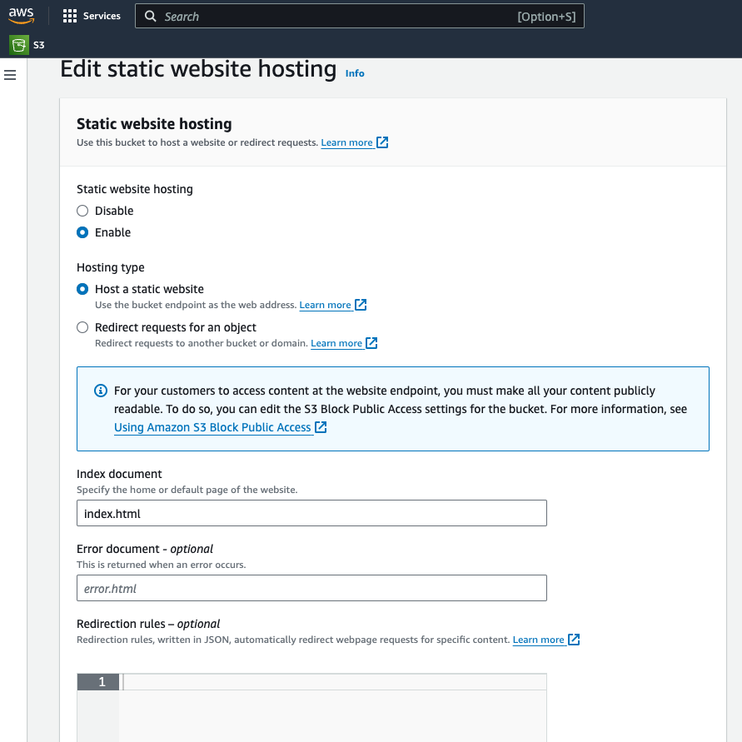

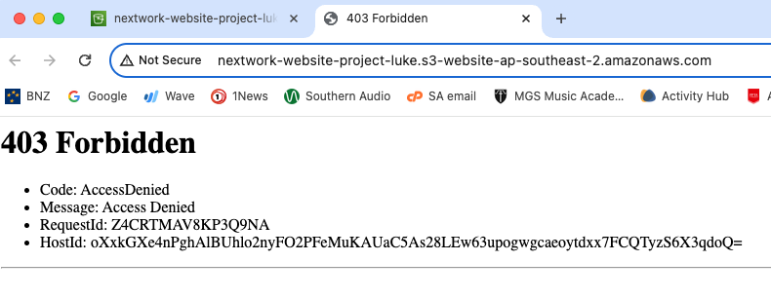

💡 Why? Objects (in this case, the HTML and images files you uploaded) stored in S3 are private by default. This setting helps keep your account's data secure.  
This error message you're seeing is telling you that that your static website is being hosted by S3, but that the actual HTML/image files are still private.  
To solve this error, we need to set the permission of the objects to public - this is why we enabled ACLs in Task 1!



